**Sharvan Ram Kumaran**

**CSE-C**

**185001143**

**Assignment 7-Create React Application for Conference**

**Code:**

**App.js:**

import {

BrowserRouter as Router,

Switch,

Route,

Link

} from "react-router-dom";

import './App.css';

import Home from './components/home';

import Committee from './components/committee';

import CallForPapers from './components/CallForPapers';

import Important from './components/important';

import Workshops from './components/workshops';

import Register from './components/register';

import Contacts from './components/contact';

function App() {

return (

<>

<title>Conference</title>

<Router>

<div>

<nav className="nav main-nav">

<ul>

<li><Link to="/">Home</Link></li>

<li><Link to="/Committee">Committee</Link></li>

<li><Link to="/CallForPapers">Call For Papers</Link></li>

<li><Link to="/Important">Important Dates</Link></li>

<li><Link to="/Workshops">Workshops</Link></li>

<li><Link to="/Register">Register</Link></li>

<li><Link to="/Contacts">Contacts</Link></li>

</ul></nav>

<Switch>

<Route exact path="/">

<Home />

</Route>

<Route path="/Committee">

<Committee />

</Route>

<Route path="/CallForPapers">

<CallForPapers />

</Route>

<Route path="/Important">

<Important />

</Route>

<Route path="/Workshops">

<Workshops />

</Route>

<Route path="/Register">

<Register />

</Route>

<Route path="/Contacts">

<Contacts />

</Route>

</Switch>

</div>

</Router>

</>

);

}

export default App;

**Home.js:**

import React from 'react';

import tulum from '../images/tulum.jpeg';

import speaker from '../images/circle-cropped.png';

function Home(){

return (

<>

<header>

<div style={{backgroundColor:"powderBlue"}}>

<h1>International Nature Conference - June 10,11,12</h1>

</div>

</header>

<h1>Conference Home Page</h1>

<p>This is the home page for the International Nature Conference, scheduled to take place at SSN College of Engineering, this June.</p>

<table style={{margin:"auto"}}>

<tr><td><img src={tulum} alt="Tulum" style={{marginTop:"15px"}}/></td></tr>

<tr>

<td><h1>Purity</h1>

<p>The sunny shores of Tulum are said to be among the healthiest waters this year, as can be seen from the booming wildlife underwater. This can be witnessed firsthand by scuba diving from any of the numerous tourist centres.</p>

</td>

</tr>

</table>

<hr/>

<h1>Keynote Speaker</h1>

<table>

<tr><td><img src={speaker} alt="Tulum" style={{marginTop:"15px"}}/></td></tr>

<tr>

<td><h1>Sir David Frederick Attenborough</h1>

<p>An english broadcaster and natural historian, he is definitely one of the most proilific names in this sphere, having voiced and produced numerous nature documentaries to educate children on the importance of natural resources. His knowledge of our planet's ecosystems is unparalled and is sure to impart some vital knowledge during this conference.</p>

</td>

</tr>

</table>

<hr/>

<h1>List of topics</h1>

<ul>

<li>Re-emerging species</li>

<li>Loss of ecosystem</li>

<li>Pollution control systems</li>

<li>Achievements in the restoring nature</li>

</ul>

<footer>

<div style={{backgroundColor: "gray"}}>

<h1>Looking forward to your Participation at our campus this year!</h1>

</div>

</footer>

</>

);

}

export default Home;

**Committee.js:**

import React from 'react';

function Committee(){

return(

<>

<header>

<div style={{backgroundColor:"powderBlue"}}>

<h1>International Nature Conference - June 10,11,12</h1>

</div>

</header>

<h1>Conducting Committee</h1>

<p> This is the committee that has organized every facet of the conference</p>

<table cellspacing="20" style={{margin:"auto"}}>

<tr>

<th>Committee</th>

<th>Committee Head</th>

<th>Department</th>

<th>Contact</th>

</tr>

<tr>

<td><h4>Fauna Committee</h4></td>

<td><h4>Aditya KP</h4></td>

<td><h4>CSE</h4></td>

<td><h4><a href="mailto:adityakp@gmail.com" style={{textDecoration:"none"}}>adityakp@gmail.com</a></h4></td>

</tr>

<tr>

<td><h4>Flora Committee</h4></td>

<td><h4>Avinash Kartik</h4></td>

<td><h4>CSE</h4></td>

<td><h4><a href="mailto:avinash@gmail.com" style={{textDecoration:"none"}}>avinash@gmail.com</a></h4></td>

</tr>

<tr>

<td><h4>Decorations Committee</h4></td>

<td><h4>Vrishin Vigneshwar</h4></td>

<td><h4>CSE</h4></td>

<td><h4><a href="mailto:vrishin@gmail.com" style={{textDecoration:"none"}}>vrishin@gmail.com</a></h4></td>

</tr>

<tr>

<td><h4>Logistics Committee</h4></td>

<td><h4>Shivanirudh</h4></td>

<td><h4>CSE</h4></td>

<td><h4><a href="mailto:shiva@gmail.com" style={{textDecoration:"none"}}>shiva@gmail.com</a></h4></td>

</tr>

</table>

<footer style={{marginTop: 153}}>

<div style={{backgroundColor: "gray"}}>

<h1>Looking forward to your Participation at our campus this year!</h1>

</div>

</footer>

</>

);

}

export default Committee;

**CallForPapers.js:**

import React from 'react';

function CallForPapers(){

return(

<>

<header>

<div style={{backgroundColor:"powderBlue"}}>

<h1>International Nature Conference - June 10,11,12</h1>

</div>

</header>

<h1>Call for Papers</h1>

<h2>The Nature conference invites the submission of regular and short papers on substantial, original, and unpublished research in all aspects of Wildlife, Sustainability, Pollution, New Species and Urban Nature.</h2>

<br/>

<h4>Relevant topics for the conference include, but are not limited to, the following areas:</h4>

<ol style={{textAlign:"center"}}>

<li>Adapting to Urbanization</li>

<ul style={{textAlign:"center"}}>

<li>Encroached Territories</li>

<li>Rooftop forests</li>

<li>Structural damage from Fauna</li>

</ul>

<li>New Species</li>

<ul>

<li>Hybrid Theory</li>

<li>Unlikely Habitats</li>

<li>Discoveries</li>

</ul>

<li>Pollution</li>

<ul>

<li>New control measures</li>

<li>New threats</li>

<li>Effect on wildlife</li>

</ul>

</ol>

<hr/>

<h1>Submission Guidelines</h1>

<h4>Regular Papers</h4>

<p>Regular Nature Conference 21 submissions must describe substantial, original, completed and unpublished work. Wherever appropriate, concrete evaluation and analysis should be included. Review forms will be made available prior to the deadlines.</p>

<p>Regular papers may consist of 12 - 15 pages of content including references.</p>

<h4>Short Papers</h4>

<p>Nature Conference 21 also solicits short papers. Short paper submissions must describe original and unpublished work. Short papers should have a point that can be made in a few pages. Some kinds of short papers are:</p>

<ul>

<li>A small, focused contribution</li>

<li>Work in progress</li>

<li>Experience Papers</li>

<li>Survey Papers</li>

<li>A negative results</li>

<li>An opinion piece</li>

</ul>

<p>Short papers may consist of 6 - 8 pages including references.Short papers will be presented in one or more oral or poster sessions. While short papers will be distinguished from regular papers in the proceedings, there will be no distinction in the proceedings between short papers presented orally and as posters.</p>

<h4>Submission format</h4>

<p>Authors must follow the Springer LNCS formatting instructions. For camera-ready papers use Latex or Word style (Author’s instruction page ). Each paper will receive at least three reviews. At least one author of each accepted paper must register by the early registration date indicated on the conference website and present the paper.</p>

<hr/>

<h2>Publication</h2>

<p>Accepted papers that are presented at the conference will be included in the conference proceedings and published in the Springer IFIP AICT (Advances in Information and Communication Technology ) series. Volumes published will be indexed in Conference Proceedings Citation Index (CPCI) - part of Clarivate Analytics’ Web of Science, EI Engineering Index, ACM Digital Library, DBLP, Google Scholar and Scopus.</p>

<footer>

<div style={{backgroundColor: "gray"}}>

<h1>Looking forward to your Participation at our campus this year!</h1>

</div>

</footer>

</>

);

}

export default CallForPapers;

**Important.js:**

import React from 'react';

function Important(){

return(

<>

<header>

<div style={{backgroundColor:"powderBlue"}}>

<h1>International Nature Conference - June 10,11,12</h1>

</div>

</header>

<h1 style = {{textAlign: "center"}}>Important Dates</h1>

<p style = {{textAlign: "center"}}>Paper Submission Opens: 20th February 2021</p>

<p style = {{textAlign: "center"}}>Paper Submission Closes: 20th April 2021</p>

<p style = {{textAlign: "center"}}>Acceptance Notification: 29th April 2021</p>

<p style = {{textAlign: "center"}}>Camera Ready Submission May 20th, 2021(including registration of authors and payments)</p>

<p style = {{textAlign: "center"}}>Pre Conference Workshop: 10th June 2021</p>

<p style = {{textAlign: "center"}}>Conference:June 10,11 and 12, 2021</p>

<footer style={{marginTop:"389px"}}>

<div style={{backgroundColor: "gray"}}>

<h1>Looking forward to your Participation at our campus this year!</h1>

</div>

</footer>

</>

);

}

export default Important;

**Workshops.js:**

import React from 'react';

function Workshops(){

return(

<>

<header>

<div style={{backgroundColor:"powderBlue"}}>

<h1>International Nature Conference - June 10,11,12</h1>

</div>

</header>

<h1 style={{textAlign:"center"}}>Pre Conference Workshops</h1>

<h2 style={{textAlign:"center"}}>Workshops will be conducted in two tracks:</h2>

<h2 style={{textAlign:"center"}}>Track 1: Urbanization and Nature</h2>

<h2 style={{textAlign:"center"}}>Track 2: Hybrid Theory</h2>

<footer style={{marginTop:"453px"}}>

<div style={{backgroundColor: "gray"}}>

<h1>Looking forward to your Participation at our campus this year!</h1>

</div>

</footer>

</>

);

}

export default Workshops;

**Register.js:**

import React from 'react';

function Register(){

return (

<>

<header>

<div style={{backgroundColor:"powderBlue"}}>

<h1>International Nature Conference - June 10,11,12</h1>

</div>

</header>

<h1 style={{textAlign:"center"}}>Registration form</h1>

<h4 style={{textAlign:"center"}}>Sign up for the conference here!</h4>

<form action="/action_page.php" style={{textAlign:"center"}}>

<label for="name">Name:</label><br/>

<input type="text" id="name" name="name" value=""/><br/>

<label for="email">Email:</label><br/>

<input type="email" id="email" name="email" value=""/><br/>

<label for="num">Number:</label><br/>

<input type="tel" id="num" name="num" value=""/><br/>

<label for="college">College:</label><br/>

<input type="text" id="college" name="college" value=""/><br/>

<label for="dept">Department:</label><br/>

<input type="text" id="dept" name="dept" value=""/><br/>

<input type="submit" value="Submit"/>

</form>

<footer style={{marginTop:"310px"}}>

<div style={{backgroundColor: "gray"}}>

<h1>Looking forward to your Participation at our campus this year!</h1>

</div>

</footer>

</>

);

}

export default Register;

**Contact.js:**

import React from 'react';

function Contact(){

return(

<>

<header>

<div style={{backgroundColor:"powderBlue"}}>

<h1>International Nature Conference - June 10,11,12</h1>

</div>

</header>

<h1>Contact</h1>

<table style={{margin:"auto"}} cellspacing="20">

<tr>

<th>Name</th>

<th>Email</th>

<th>Contact No.</th>

</tr>

<tr>

<td>Aditya KP</td>

<td><a href="mailto:adityakp@gmail.com" style={{textDecoration:"none"}}>adityakp@gmail.com</a></td>

<td>9444767978</td>

</tr>

<tr>

<td>Avinash Kartik</td>

<td><a href="mailto:avinash@gmail.com" style={{textDecoration:"none"}}>avinash@gmail.com</a></td>

<td>9444767989</td>

</tr>

<tr>

<td>Vrishin Vigneshwar</td>

<td><a href="mailto:vrishin@gmail.com" style={{textDecoration:"none"}}>vrishin@gmail.com</a></td>

<td>9444767912</td>

</tr>

<tr>

<td>Shivanirudh</td>

<td><a href="mailto:shiva@gmail.com" style={{textDecoration:"none"}}>shiva@gmail.com</a></td>

<td>9444762334</td>

</tr>

</table>

<footer style={{marginTop:"356px"}}>

<div style={{backgroundColor: "gray"}}>

<h1>Looking forward to your Participation at our campus this year!</h1>

</div>

</footer>

</>

);

}

export default Contact;

**App.css:**

.title {

text-align: center;

color:white;

padding-top: 30px;

}

.nav ul {

margin: 0;

}

.nav li {

display: inline;

}

.nav a {

display: inline-block;

padding: 0.5em;

color: white;

text-decoration: none;

}

.main-nav {

text-align: center;

font-size: 1.1em;

font-weight: lighter;

border-bottom: 1px solid rgba(255, 255, 255, 0.3);

background-color: rgba(0, 0, 0, 0.6);

background-image: black;

background-blend-mode: multiply;

background-size: cover;

}

.main-nav li {

padding: 0 2.5%;

}

.nav a:hover {

background-color: rgba(255, 255, 255, 0.3);

}

body{

background: linear-gradient(45deg, rgba(29,224,153,0.8), rgba(29,200,205,0.8)), url(images/waterfall.jpg);

background-size: cover;

background-attachment: fixed;

height: 100vh;

text-align: center;

}

**Output:**

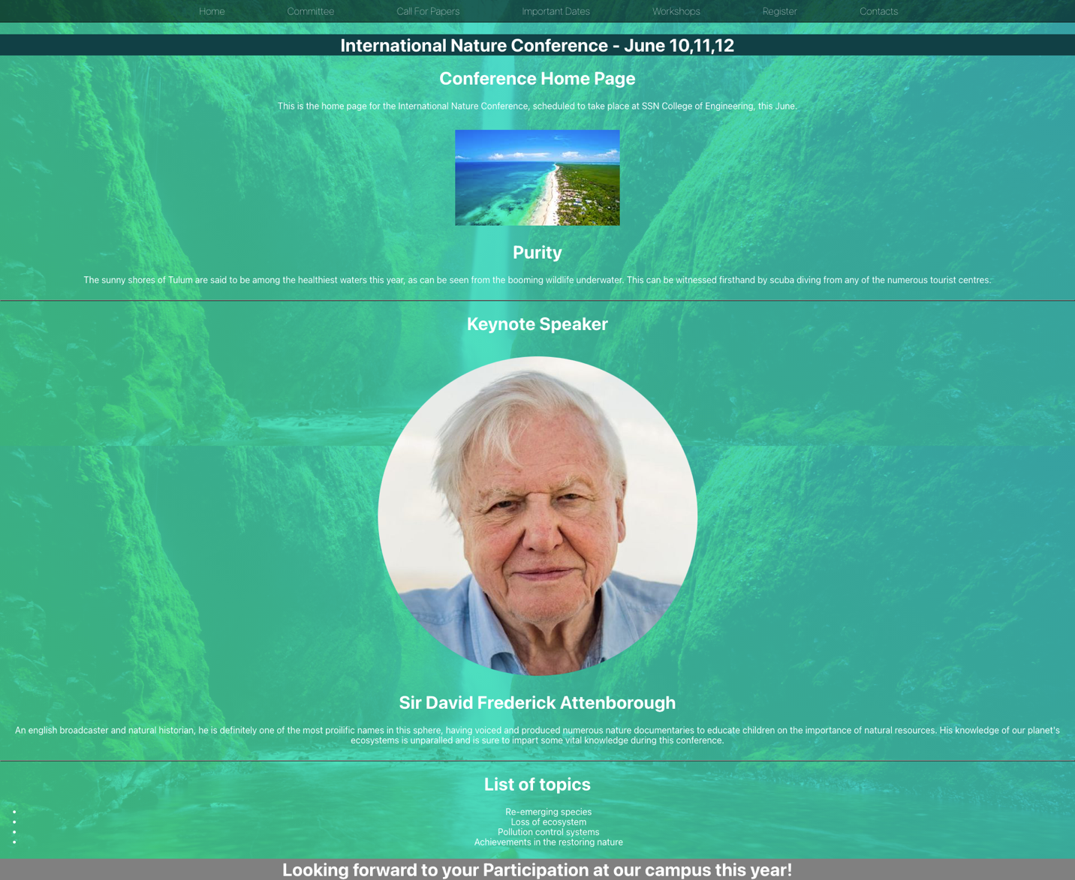

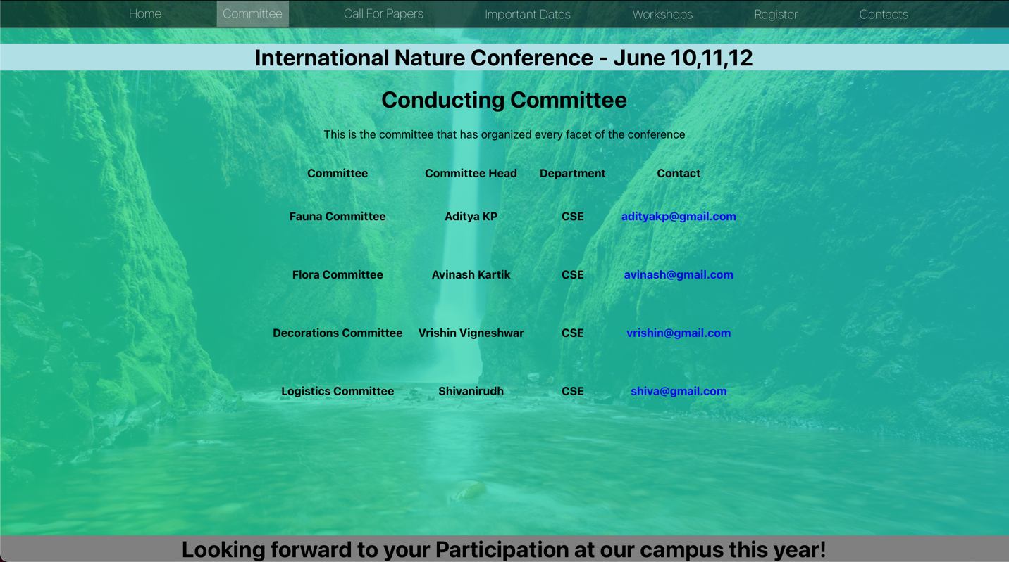

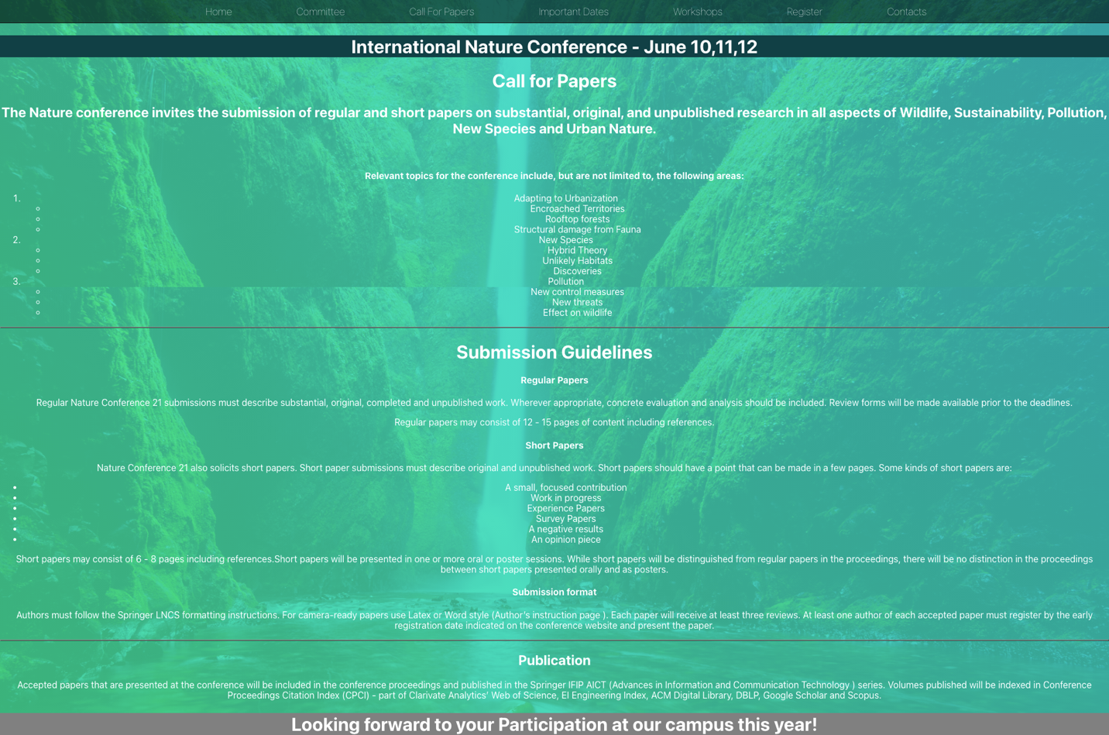

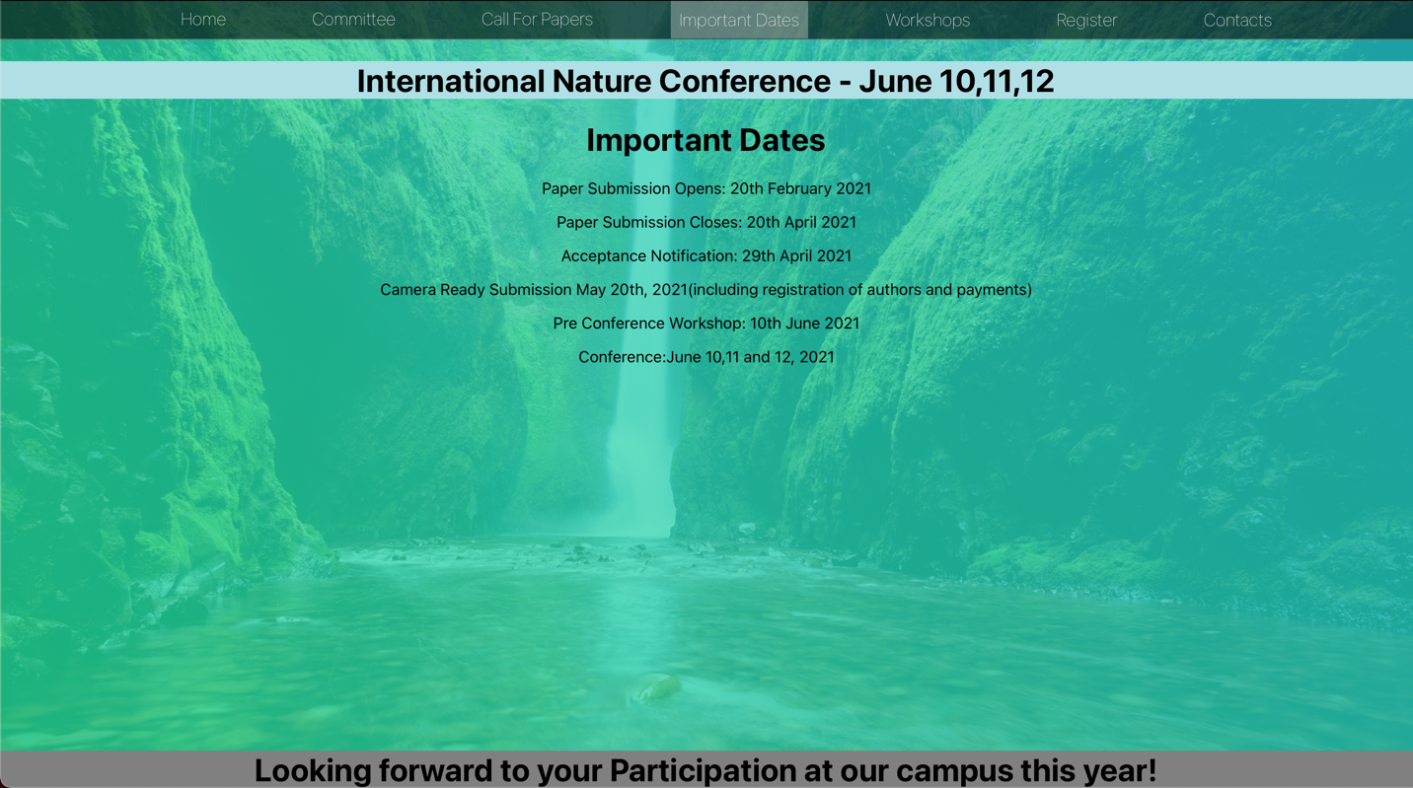

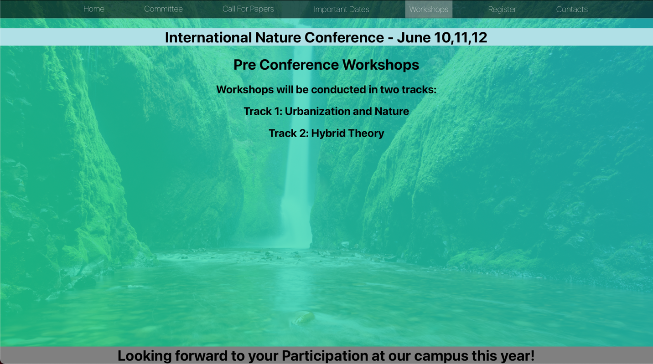

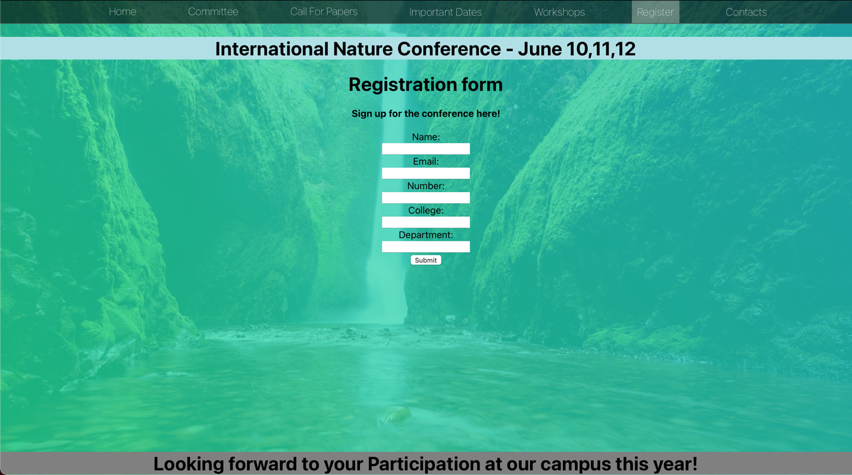

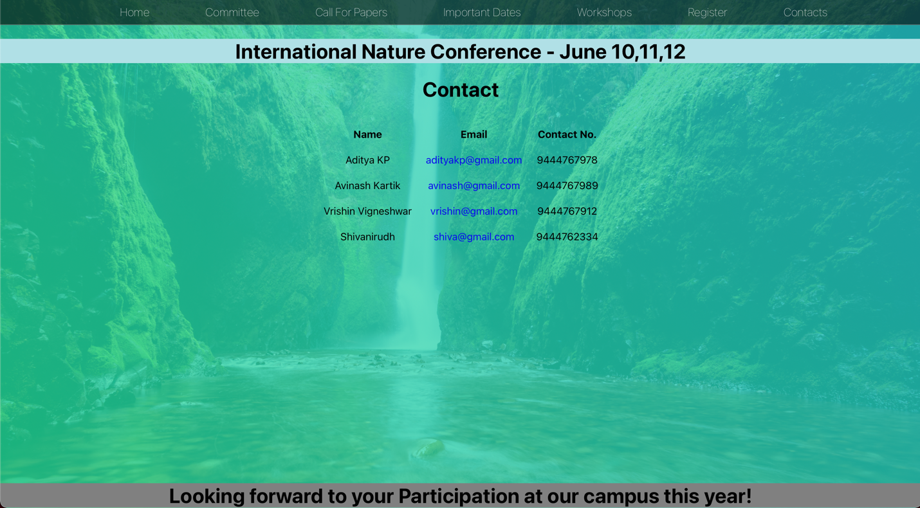

**Learning Outcome:**

The Website for the conference was created using React concepts.